UNIVERSITY OF MINNESOTA

Twin Cities Campus Division of Epidemiology & Community Health Suite 300 West Bank Office Building
School of Public Health 1300 South Second Street
School of Public Health
Minneapolis, MN 55454-1015
Office: 612-624-1818

April 26, 2022

Ryan Larson
1535 E 24th St
Minneapolis, MN 55404
EmplID: 4006367

Dear Ryan:

I am very pleased to offer you the position of Casual (consistently 14 hours a week or less) in the Division of Epidemiology and Community Health at the University of Minnesota School of Public Health. Your starting date will be May 9, 2022 with an ending date no later than August 28, 2022. The legal name, address and phone number of the employer is University of Minnesota, 100 Donhowe Building, 319 15th Ave. SE, Minneapolis MN 55455; (800) 756-2363.

The specifics of this offer are outlined below:

- Your hourly pay rate is $25.30. You must submit your time via an electronic timesheet in MyU > My Time (www.myu.umn.edu), and you will be paid bi-weekly (every other Wednesday). You can expect your first paycheck on June 1, 2022.
- I will be your supervisor.
- Federal law requires that all employees be authorized to work in the United States. This employment offer is contingent upon verification that you meet this requirement. In addition, if you are here on a non-immigrant visa, you must be authorized specifically to work at the University of Minnesota. Regardless of your citizenship status, you must: 1) complete and submit Section 1 of the I-9 Form found at http://www.newi9.com on or before your first day of work for pay, 2) provide the required I-9 documentation described on the I-9 form to establish your identity and authorization to work on or before your first day of work for pay, and 3) receive confirmation from the University that your documentation satisfies the federal law requirements. Your employment, including any rights and privileges afforded under the University's codes, policies, and agreements applicable to your position, does not begin until all of these steps have been completed. If you report to your first day of work without the required I-9 documentation, you will not be allowed to start work, or remain in the workplace until you present the required documents. Instructions on how to complete your I-9 verification will be sent closer to your start date. If you do not receive this information or have questions, please contact Kelly Rosemark at epichpay@umn.edu.
- As with all new positions, this offer is contingent upon the successful completion of a background check. You will receive an email from the University’s background check vendor, HireRight, which will include the link to confidentially enter your personal information and give authorization for the check. Please enter your information as soon as possible after receiving the link from HireRight Customer Support.

- You will not have to pay union dues or fair share dues under this type of appointment.
- This position is non-exempt under the federal Fair Labor Standards Act and applicable Minnesota law, which means you are eligible for overtime pay for all hours worked over 40 in a work week. All overtime hours must be pre-approved by your supervisor.
- Deductions will be taken from your paycheck as required by law for federal and state income tax withholding. There will be a deduction of 6.2% for Social Security (Old-Age, Survivors and Disability Insurance) up to the applicable income limit and 1.45% for Medicare.
- Under this appointment, you are not eligible for sick leave; vacation; health plan benefits; Regents’ Scholarship; retirement plans; or layoff rights.
- You are responsible for continuing to comply with any and all licensing, certification or other requirements for the position.
- You have a right to review your personnel file once every six months while employed with the University of Minnesota. To exercise this right, you must submit a written request to review your file to sph-hr@umn.edu. If, after reviewing your file, you dispute specific information, please inform sph-hr@umn.edu. The University may agree to remove or revise the disputed information. After you have had an opportunity to review your file, you may make a written request for a copy of the record at no cost to you.
- To comply with the University’s Administrative Policy: COVID-19 Vaccination and Safety Protocol Requirements for University Employees and Student Workers, on your first day of employment you must submit documentation as follows:
  - Proof that at least 14 days have passed after administration of a single dose of the Janssen/Johnson & Johnson vaccine, or 14 days have passed after administration of the second dose of any other acceptable COVID-19 Vaccine; OR
  - A completed request for an exemption using either the medical exemption form or religious exemption form.
Acceptable COVID-19 vaccines are those approved or authorized for use by the U.S. Food and Drug Administration or World Health Organization to prevent COVID-19. Vaccines meeting this definition currently include Pfizer-BioNTech (Comirnaty, Tozinameran), Moderna (Spikevax), Janssen/Johnson & Johnson, AstraZeneca/Oxford (Vaxzevria), Bharat Biotech/Covaxin, Serum Institute of India/Covishield, Sinopharm/Beijing (Covilo), and Sinovac/CoronaVac.
Acceptable proof of vaccination includes the following documentation:
  - A digital image of the covered individual’s completed CDC COVID-19 Vaccination Record Card (must be the card provided by the medical provider or pharmacist that administered the shot(s)); OR
  - A digital image of the covered individual’s record of COVID-19 vaccination from the Minnesota Department of Health Minnesota Immunization Connection (MIIC) or another official state immunization information system. Covered Individuals can link to this system using the Docket app, which is available for multiple phone and computer platforms; OR
  - A digital image of the Covered Individual’s record of COVID-19 vaccination prepared by the health care provider or pharmacy that administered the shot(s).

For parking and transportation information, refer to http://www1.umn.edu/pts/ or call (612) 626-7275.

This constitutes our entire employment offer to you under this appointment. There are no implied or verbal agreements or promises outside of this letter.

I would be happy to answer any questions you may have or provide clarity on your appointment. Should you decide to accept this position, please sign and date the original of this letter indicating that you have read and fully understand the provisions of your employment as explained in this letter and return a copy to me.

I look forward to receiving your favorable reply.

Sincerely,

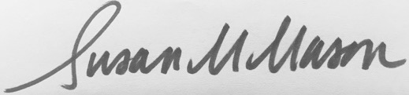

Susan Mason, PhD, MPH
Associate Professor
Epidemiology and Community Health

cc: SPH Personnel
EpiCH Personnel

*************************************************************************************
I accept the position of Casual (consistently 14 hours a week or less) in the Division of Epidemiology and Community Health in the School of Public Health and acknowledge receipt of this offer letter.

______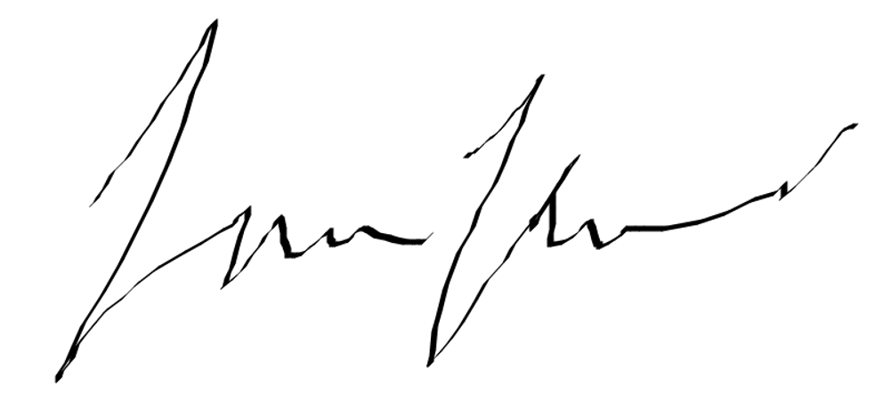______ _______4/27/2022_____________
Ryan Larson Date

This document contains important information about your employment. Check the box at left to receive this information in this language.

